# Project Development Phase Sprint-1

|  |  |
| --- | --- |
| Date | 29 October 2022 |
| Team ID | PNT2022TMID53935 |
| Project Name | Real-Time River Water Quality  Monitoring and Control System |

**1.Design of Mobile App UI with login feature for getting sensor values**

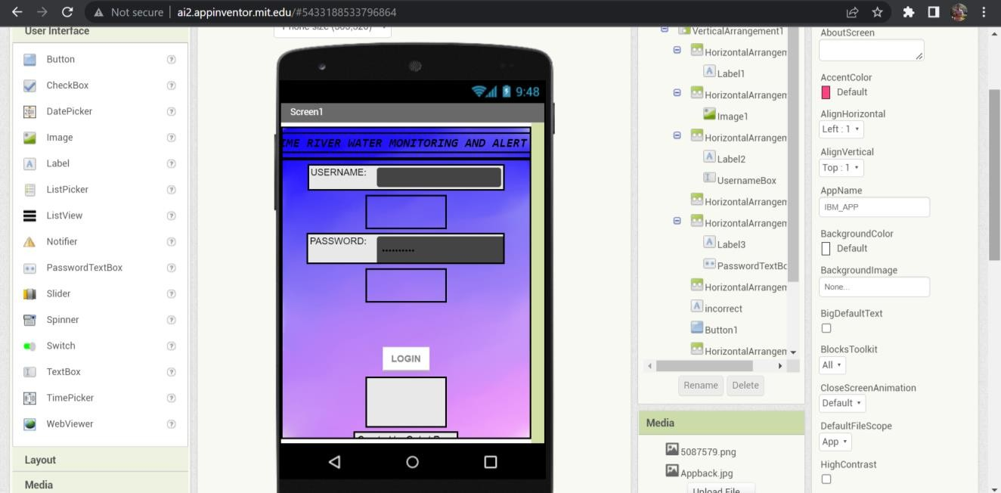Frontend Design Screen 1:

Frontend Design Screen 2:

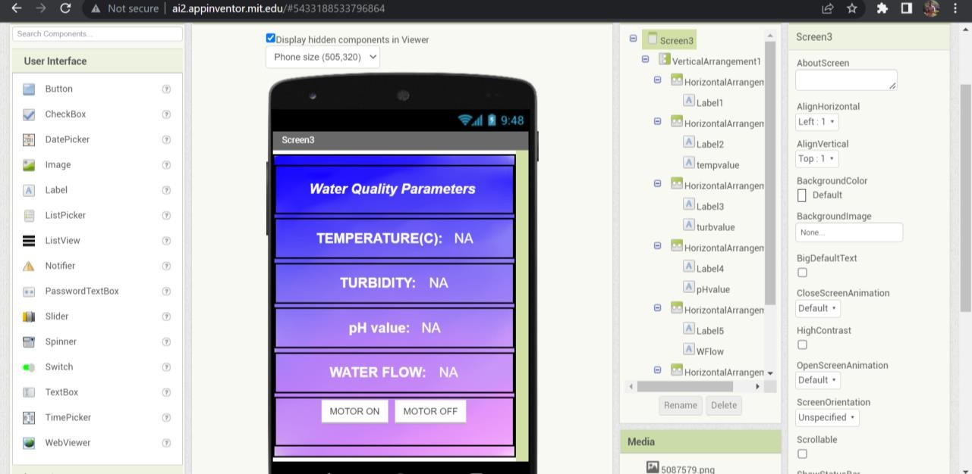

Backend :

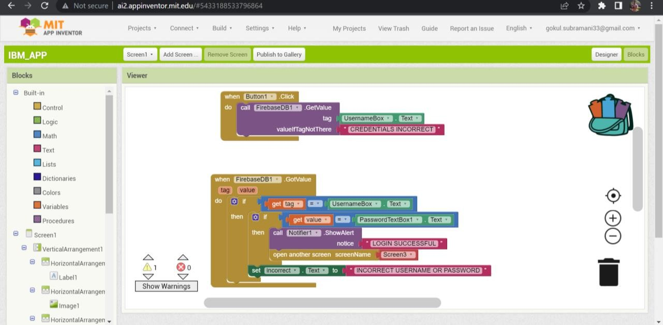

Firebase db for storing login credentials:

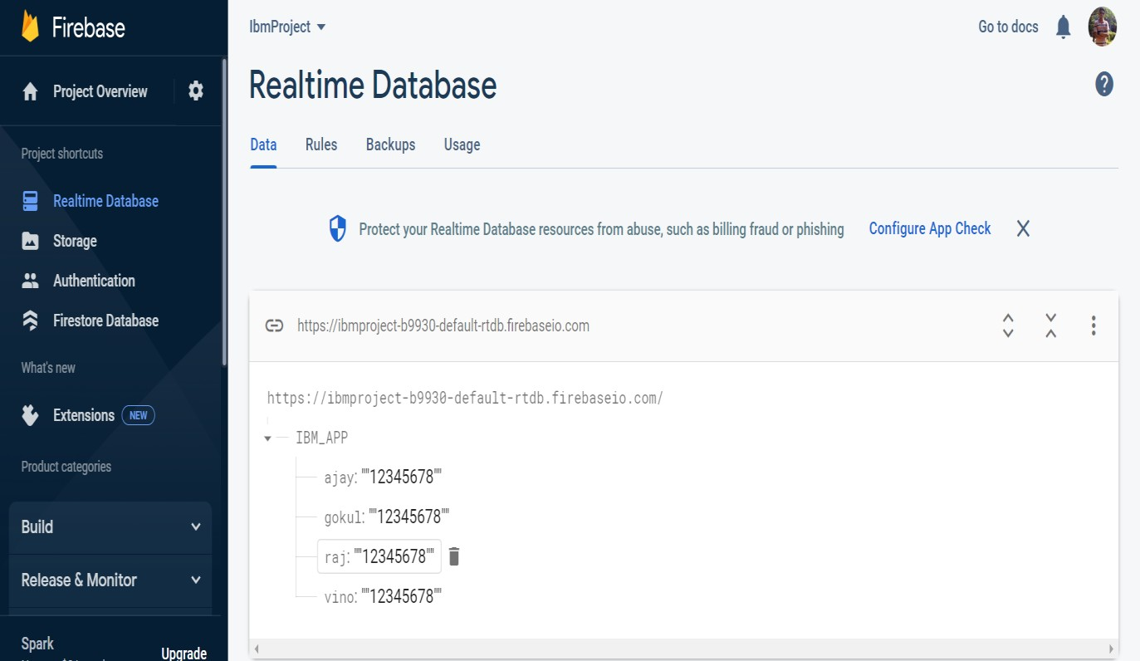

# Testing the designed app:

1. Incorrect login information are tested.

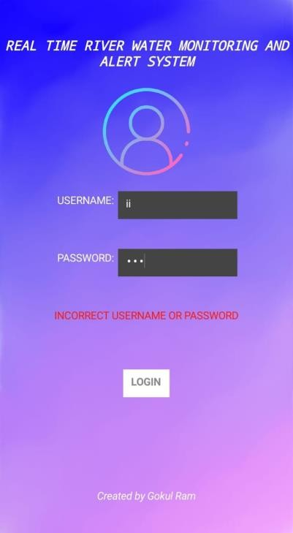

1. Upon successful login

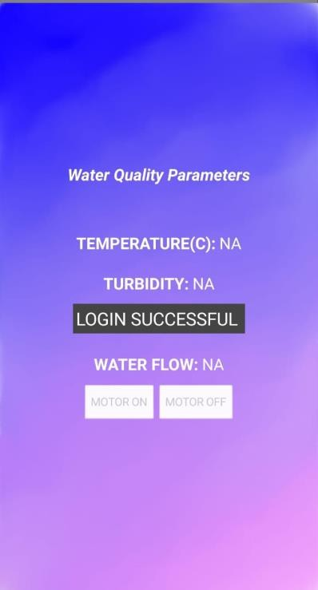

1. Display of different sensor values

